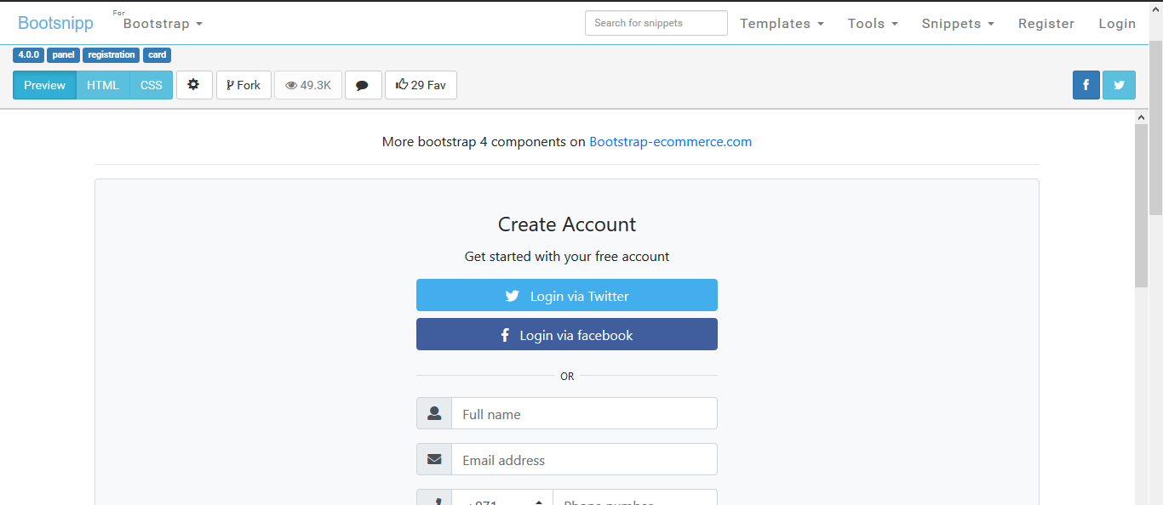

**<link href="//maxcdn.bootstrapcdn.com/bootstrap/4.0.0/css/bootstrap.min.css" rel="stylesheet" id="bootstrap-css">**

**<script src="//maxcdn.bootstrapcdn.com/bootstrap/4.0.0/js/bootstrap.min.js"></script>**

**<script src="//cdnjs.cloudflare.com/ajax/libs/jquery/3.2.1/jquery.min.js"></script>**

**<!------ Include the above in your HEAD tag ---------->**

**<link rel="stylesheet" href="https://use.fontawesome.com/releases/v5.0.8/css/all.css">**

**<div class="container">**

**<br> <p class="text-center">More bootstrap 4 components on <a href="http://bootstrap-ecommerce.com/"> Bootstrap-ecommerce.com</a></p>**

**<hr>**

**<div class="card bg-light">**

**<article class="card-body mx-auto" style="max-width: 400px;">**

**<h4 class="card-title mt-3 text-center">Create Account</h4>**

**<p class="text-center">Get started with your free account</p>**

**<p>**

**<a href="" class="btn btn-block btn-twitter"> <i class="fab fa-twitter"></i>   Login via Twitter</a>**

**<a href="" class="btn btn-block btn-facebook"> <i class="fab fa-facebook-f"></i>   Login via facebook</a>**

**</p>**

**<p class="divider-text">**

**<span class="bg-light">OR</span>**

**</p>**

**<form>**

**<div class="form-group input-group">**

**<div class="input-group-prepend">**

**<span class="input-group-text"> <i class="fa fa-user"></i> </span>**

**</div>**

**<input name="" class="form-control" placeholder="Full name" type="text">**

**</div> <!-- form-group// -->**

**<div class="form-group input-group">**

**<div class="input-group-prepend">**

**<span class="input-group-text"> <i class="fa fa-envelope"></i> </span>**

**</div>**

**<input name="" class="form-control" placeholder="Email address" type="email">**

**</div> <!-- form-group// -->**

**<div class="form-group input-group">**

**<div class="input-group-prepend">**

**<span class="input-group-text"> <i class="fa fa-phone"></i> </span>**

**</div>**

**<select class="custom-select" style="max-width: 120px;">**

**<option selected="">+971</option>**

**<option value="1">+972</option>**

**<option value="2">+198</option>**

**<option value="3">+701</option>**

**</select>**

**<input name="" class="form-control" placeholder="Phone number" type="text">**

**</div> <!-- form-group// -->**

**<div class="form-group input-group">**

**<div class="input-group-prepend">**

**<span class="input-group-text"> <i class="fa fa-building"></i> </span>**

**</div>**

**<select class="form-control">**

**<option selected=""> Select job type</option>**

**<option>Designer</option>**

**<option>Manager</option>**

**<option>Accaunting</option>**

**</select>**

**</div> <!-- form-group end.// -->**

**<div class="form-group input-group">**

**<div class="input-group-prepend">**

**<span class="input-group-text"> <i class="fa fa-lock"></i> </span>**

**</div>**

**<input class="form-control" placeholder="Create password" type="password">**

**</div> <!-- form-group// -->**

**<div class="form-group input-group">**

**<div class="input-group-prepend">**

**<span class="input-group-text"> <i class="fa fa-lock"></i> </span>**

**</div>**

**<input class="form-control" placeholder="Repeat password" type="password">**

**</div> <!-- form-group// -->**

**<div class="form-group">**

**<button type="submit" class="btn btn-primary btn-block"> Create Account </button>**

**</div> <!-- form-group// -->**

**<p class="text-center">Have an account? <a href="">Log In</a> </p>**

**</form>**

**</article>**

**</div> <!-- card.// -->**

**</div>**

**<!--container end.//-->**

**<br><br>**

**<article class="bg-secondary mb-3">**

**<div class="card-body text-center">**

**<h3 class="text-white mt-3">Bootstrap 4 UI KIT</h3>**

**<p class="h5 text-white">Components and templates <br> for Ecommerce, marketplace, booking websites**

**and product landing pages</p> <br>**

**<p><a class="btn btn-warning" target="_blank" href="http://bootstrap-ecommerce.com/"> Bootstrap-ecommerce.com**

**<i class="fa fa-window-restore "></i></a></p>**

**</div>**

**<br><br>**

**</article>**

**Css**

**.divider-text {**

**position: relative;**

**text-align: center;**

**margin-top: 15px;**

**margin-bottom: 15px;**

**}**

**.divider-text span {**

**padding: 7px;**

**font-size: 12px;**

**position: relative;**

**z-index: 2;**

**}**

**.divider-text:after {**

**content: "";**

**position: absolute;**

**width: 100%;**

**border-bottom: 1px solid #ddd;**

**top: 55%;**

**left: 0;**

**z-index: 1;**

**}**

**.btn-facebook {**

**background-color: #405D9D;**

**color: #fff;**

**}**

**.btn-twitter {**

**background-color: #42AEEC;**

**color: #fff;**

**}**